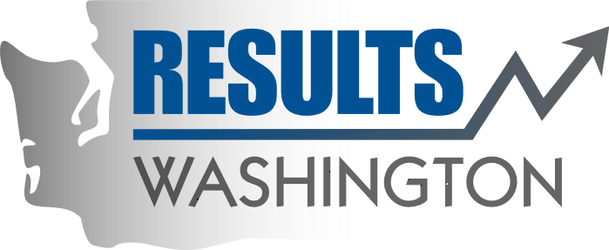

Governor’s Results Review Agenda

Reducing Youth Recidivism

Date: | February 26, 2020
Time: | 10:30-12:00
Location: | Helen Sommers Building, 106 11th Ave, Olympia, WA 98504, Room G015

Time | Topic | Participants
10:30 – 10:40 | Welcome | Mandeep Kaundal, Results Washington  Governor Jay Inslee
10:40 – 10:48 | Neuroscience | - Teri Barila, Chief Executive Officer, Community Resilience Initiative (Zoom attendee)
10:48 – 11:01 | Department of Children Youth & Families / JR Rehab model | - Ross Hunter, Secretary, Department of Children Youth & Families
11:01 – 11:06 | Green Hill School Youth Council Members –Youth – Led Training on Trauma | - Christian, Green Hill School Council Member  - Aaron, Green Hill School Council Member
11:06 – 11:11 | Q&A | Governor Jay Inslee
11:11 – 11:16 | Guided Pathways for Education | - Brian Walsh, Senior Program Associate, Vera Institute of Justice (Zoom attendee)
11:16 – 11:26 | Guided Pathways for Education and Employment | - Lynn Strickland, Executive Director, Aerospace Joint Apprenticeship Committee  - Cheryl Fambles, Chief Executive Officer, PacMountain
11:26 – 11:31 | Youth Success Story | - Diontae, Manufacturing Academy Graduate
11:31 – 11:36 | Q&A | Governor Jay Inslee
11:36 – 11:43 | Office of Homeless Youth – Leveraging Lived Experiences | - Kim Justice, Executive Director, Office of Homeless Youth
11:43 – 11:50 | Housing & Support for System Gaps Impacting Youth | - Dominique Davis, Chief Executive Officer, Community Passageways
11:50 – 12:00 | Closing Remarks | Mandeep Kaundal, Results Washington  Governor Jay Inslee

Guest Speakers
Teri Barila, Chief Executive Officer, Community Resilience Initiative
Our community-building framework and 21 years’ experience in capacity building is the essence of what created the platform for the documentary Paper Tigers. From its beginning, CRI has focused on building community capacity to mitigate the effects of ACEs and build Resilience through collaborations and partnerships.
Ross Hunter, Secretary, Department of Children Youth & Families
- Christian, Green Hill School Council Member
- Aaron, Green Hill School Council Member
- Diontae, Manufacturing Academy Graduate

DCYF is a cabinet-level agency focused on the well-being of children. Our vision is to ensure that "Washington state’s children and youth grow up safe and healthy—thriving physically, emotionally and academically, nurtured by family and community."
Brian Walsh, Senior Program Associate, Vera Institute of Justice

Our mission is to drive change. To urgently build and improve justice systems that ensure fairness, promote safety, and strengthen communities. We work with others who share our vision to tackle the most pressing injustices of our day—from the causes and consequences of mass incarceration, racial disparities, and the loss of public trust in law enforcement, to the unmet needs of the vulnerable, the marginalized, and those harmed by crime and violence.
Lynn Strickland, Executive Director, Aerospace Joint Apprenticeship Committee
From Seattle to Spokane, the Aerospace Joint Apprenticeship Committee (AJAC) is committed to the the development, implementation and maintenance of thriving apprenticeship and pre-apprenticeship programs for the purpose of creating the next generation of highly skilled manufacturing workers in Washington State. Find out who AJAC is, where our aerospace apprenticeship programs are located in Washington State, why apprenticeship works and how you can launch your career as an AJAC apprentice.
Cheryl Fambles, Chief Executive Officer, PacMountain

The Pacific Mountain Workforce Development Council (PacMtn) is a nonprofit organization that is the recognized convener of regional workforce development efforts. The PacMtn Board of Directors, PacMtn Elected Official Consortium, and all staff are dedicated to the development of a workforce system that supports business, industry, and all levels of employers and job seekers.
Kim Justice, Executive Director, Office of Homeless Youth
Every night, thousands of homeless youth in Washington go to sleep without safety, stability, and support of a family or home. Created in 2015, the Office of Homeless Youth Prevention and Protection Programs (OHY) leads the statewide efforts to reduce and prevent homelessness for youth and young adults through five priority service areas to ensure our youth and young adults have Stable Housing, Family Reconciliation, Permanent Connections, Education and Employment, and Social and Emotional Well-Being.
Dominique Davis, Chief Executive Officer, Community Passageways
Community Passageways (CP) is a Seattle based nonprofit founded in 2017 with a vision for zero youth incarceration. As a felony diversion and prevention program, CP is leading the way in reimagining and actively creating an alternative to today’s criminal legal system. We have a four-pronged approach to community justice: 1. Prevention; 2. Diversion; 3. Support; and 4. Reintegrate.

