

*“Listening is probably the most underrated leadership skill...leaders are often unable to connect with and make sense of the VUCA (volatile, uncertain, chaotic, ambiguous) world around them. Changing how you listen means that you change how you experience relationships and the world. And if you change that, you change EVERYTHING.”*

*Otto Scharmer*

**The Four Types of Listening**

**1) Downloading**: Listening is limited to reconfirming what we already know. We listen to our own inner voice. “Yeah, I know that already.”

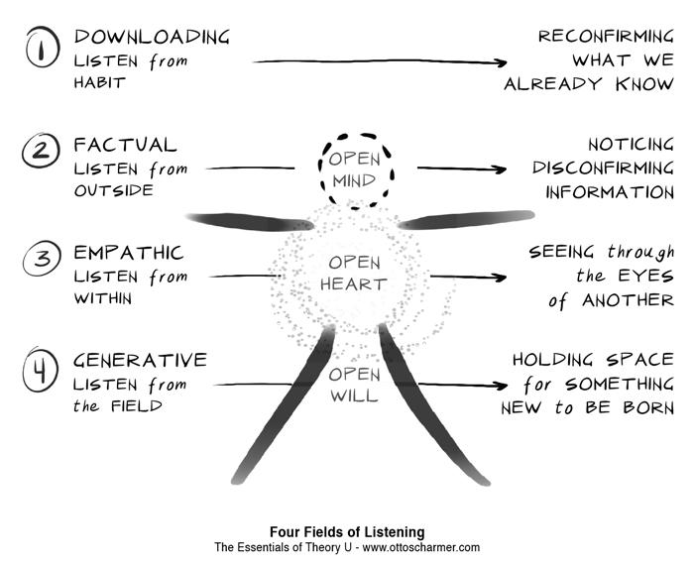**2) Factual Listening**: We let the data talk to us and notice new information. This requires the capacity to suspend our habits of judgement (open mind). “Ooh, look at that! ”

**3) Empathic Listening**: We see the situation through the eyes of another. See a new perspective. This requires the capacity to use our feelings and our heart to tune into another person’s view (open heart). “Wow, that’s how you feel? I had no idea…”

**4) Generative Listening**: We are open, curious, listen for emergent possibilities and hold space for something new. We feel it but may not have the words to describe it (open will). “Time is slowing down and we are co-creating…”

**Three Instrumental Ways of Being**

**Open mind** - the capacity to suspend old habits of judgement (**curiosity**)

**Open heart** - the capacity to empathize and look at a situation through the eyes of someone else (**compassion**)

**Open will**-the capacity to “let go” of the old and “let come” the new (**courage**)

**Reflection Questions**

Take some time to reflect on your quality of listening during the day. Estimate what percentage of time you spent at each level of listening. Here are the descriptions of each level:

**Level 1: Downloading.** Habitual listening or listening from what you already know; the result is you reconfirm what you already knew. *In what kinds of situations have you experienced downloading (your own or someone else’s)?*

**Level 2: Factual.** Noticing something new, something that differs from what you already knew or expected to hear. *When do you notice the quality of your listening changing, and what causes that to happen?*

**Level 3: Empathic.** Listening from the place from which the other person is speaking; experiencing, or sensing an emotional connection. *When you are listening empathically, how does it feel?*

**Level 4: Generative.** Connecting to the emerging future, to a future possibility that is linked to your emerging self, to who you really are. *If you have experienced generative listening, what was it like, and what shifts resulted?*

**How to Move from One Level of Listening to Another**

**From Level 1 to Level 2: Downloading → Factual Listening**Shift your attention from your own inner commentary (what you will say next) to what the person in front of you is saying (open up to what is being said). Invite curiosity and open your mind, let go of what you think they will say.

**From Level 2 to Level 3: Factual Listening → Empathic Listening**Step into the other person’s perspective (e.g.: “Oh, I may not agree, but I can see how they see the situation.”). This is a shift from the intelligence of your head to the intelligence of your heart. It requires assessing your ability to feel, to step into someone else’s place to be empathetic.

**From Level 3 to Level 4: Empathic Listening → Generative Listening**Listen with openness to what is unknown and emerging, so that your listening becomes a “holding space” for bringing something new into reality that wants to be born. You must let go of your ego.

*Adapted from: Otto Scharmer, the Presencing Institute*