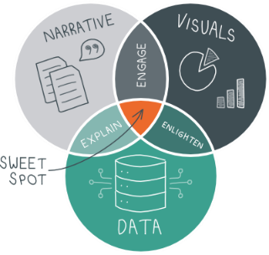
Data Visualization: What’s your Story?
WORKBOOK

This workbook is intended as a guide to help create a framework for telling your data story. It is important to know and understand the type of data we have, where it comes from, how it is entered and retrieved, and the platforms available to us. Use it “as is” or just use the prompts to help you determine who needs what information for what purpose and how often. Feel free to modify! – Beth Adams

My Data

Type of Data
What type of data do you have? Be specific (e.g., customer demographic information).

Do you have qualitative data that could easily be quantitated? ☐ Yes ☐ No ☐ Not sure
Do you have qualitative data that should be quantitated some day? ☐ Yes ☐ No ☐ Not sure

QUANTITATIVE  - ☐ Click or tap here to enter text.  - ☐ Click or tap here to enter text.  - ☐ Click or tap here to enter text.  - ☐ Click or tap here to enter text.  - ☐ Click or tap here to enter text. | QUALITATIVE  - ☐ Click or tap here to enter text.  - ☐ Click or tap here to enter text.  - ☐ Click or tap here to enter text.  - ☐ Click or tap here to enter text.  - ☐ Click or tap here to enter text.

Data Sources
What are your current data sources? What data do you need? Be specific (e.g., ProviderOne).

HAVE  - ☐ Click or tap here to enter text.  - ☐ Click or tap here to enter text.  - ☐ Click or tap here to enter text.  - ☐ Click or tap here to enter text.  - ☐ Click or tap here to enter text. | NEED  - ☐ Click or tap here to enter text.  - ☐ Click or tap here to enter text.  - ☐ Click or tap here to enter text.  - ☐ Click or tap here to enter text.  - ☐ Click or tap here to enter text.

Data Entry & Retrieval
List how you get your data. Be specific. For example:
Entry: ☒ Manual ☐ Automatic | Case managers enter client information based on assessment into CARE
Retrieval: ☐ Manual ☒ Automatic | DataMart reports for majority of CARE assessment information

Data Entry
☐ Manual ☐ Automatic | Click or tap here to enter text.
☐ Manual ☐ Automatic | Click or tap here to enter text.
☐ Manual ☐ Automatic | Click or tap here to enter text.
☐ Manual ☐ Automatic | Click or tap here to enter text.
☐ Manual ☐ Automatic | Click or tap here to enter text.

Data Retrieval
☐ Manual ☐ Automatic | Click or tap here to enter text.
☐ Manual ☐ Automatic | Click or tap here to enter text.
☐ Manual ☐ Automatic | Click or tap here to enter text.
☐ Manual ☐ Automatic | Click or tap here to enter text.
☐ Manual ☐ Automatic | Click or tap here to enter text.

Tools & Platforms

HAVE | ☐ Excel ☐ PowerBI ☐ PowerPoint ☐ SharePoint ☐ Teams ☐ Word ☐ Visio  ☐ Other: Click or tap here to enter text ☐ Other: Click or tap here to enter text
CAN USE | ☐ Excel ☐ PowerBI ☐ PowerPoint ☐ SharePoint ☐ Teams ☐ Word ☐ Visio  ☐ Other: Click or tap here to enter text ☐ Other: Click or tap here to enter text
NEED TRAINING | ☐ Excel ☐ PowerBI ☐ PowerPoint ☐ SharePoint ☐ Teams ☐ Word ☐ Visio  ☐ Other: Click or tap here to enter text ☐ Other: Click or tap here to enter text
WANT/NEED | ☐ Miro ☐ PowerBI ☐ Visio ☐ Other: Click or tap here to enter text

Storytelling

What is one story you need to tell with your data?
Thinking about that one story…

Audience
Who is/are our audience(s)? Check all that apply. Add other groups as applicable or change titles to fit your agency.

☐ Colleagues  ☐ My manager/boss  ☐ Office Chief  ☐ Division Director/Deputy  ☐ Assistant Secretary/Deputy  ☐ Agency Head/Secretary | ☐ Stakeholders  ☐ State Staff/Retirees  ☐ Funders  ☐ Legislature/Governor  ☐ Public/Community  ☐ Click or tap here to enter text. | ☐ Click or tap here to enter text.  ☐ Click or tap here to enter text.  ☐ Click or tap here to enter text.  ☐ Click or tap here to enter text.  ☐ Click or tap here to enter text.  ☐ Click or tap here to enter text.

Detail
Who needs what level of detail? Who is going to want what level of detail? Use above audience list. Generally speaking, provide the highest level of detail needed to a given group, but have the granular available upon request.
Birds Eye View Granular

☐ Add here  ☐ Add here  ☐ Add here  ☐ Add here  ☐ Add here  ☐ Add here | ☐ Add here  ☐ Add here  ☐ Add here  ☐ Add here  ☐ Add here  ☐ Add here | ☐ Add here  ☐ Add here  ☐ Add here  ☐ Add here  ☐ Add here  ☐ Add here | ☐ Add here  ☐ Add here  ☐ Add here  ☐ Add here  ☐ Add here  ☐ Add here

Who & What
Still thinking about that one story, what do you want your audience to do with the information you’re presenting? (e.g., My Office Chief needs to decide whether to continue with the pilot by January 31, 2024)

☐ Act | Who will take what action?
- Click or tap here to enter text will Click or tap here to enter text by Click or tap here to enter text
- Click or tap here to enter text will Click or tap here to enter text by Click or tap here to enter text
- Click or tap here to enter text will Click or tap here to enter text by Click or tap here to enter text

☐ Decide | Who needs to make what decisions?
- Click or tap here to enter text needs to decide Click or tap here to enter text
- Click or tap here to enter text needs to decide Click or tap here to enter text
- Click or tap here to enter text needs to decide Click or tap here to enter text
☐ Inform | Who will have what takeaways? (think learning objectives)
- Click or tap here to enter text will Click or tap here to enter text
- Click or tap here to enter text will Click or tap here to enter text
- Click or tap here to enter text will Click or tap here to enter text

Frequency
How often do you need to inform or update your audience? Use audience list from above.

daily  ☐ Add here  ☐ Add here  ☐ Add here | weekly  ☐ Add here  ☐ Add here  ☐ Add here | Bi-weekly  ☐ Add here  ☐ Add here  ☐ Add here
monthly  ☐ Add here  ☐ Add here  ☐ Add here | Bi-monthly  ☐ Add here  ☐ Add here  ☐ Add here | Quarterly  ☐ Add here  ☐ Add here  ☐ Add here
Bi-Annually  ☐ Add here  ☐ Add here  ☐ Add here | Annually  ☐ Add here  ☐ Add here  ☐ Add here | Biennially  ☐ Add here  ☐ Add here  ☐ Add here

Types of Graphs
Graphs listed in the first three columns are available in Excel and/or PowerBI. Those in the fourth column require manual manipulation (along with some patience) to create.

I’m comfortable using
☐ Area  ☐ Area, stacked  ☐ Box & whiskers  ☐ Column/Bar  ☐ Column/Bar, clustered  ☐ Column/Bar, stacked  ☐ Combo | ☐ Funnel  ☐ Histogram  ☐ Line  ☐ Pareto  ☐ Pie/donut  ☐ Gauge  ☐ Radar | ☐ Ribbon  ☐ Scatter  ☐ Stock  ☐ Surface  ☐ Treemap/Sunburst  ☐ Waterfall | Create Manually in Excel  ☐ Butterfly  ☐ Dumbbell  ☐ Lollipop

I want to be better at or start using
☐ Area  ☐ Area, stacked  ☐ Box & whiskers  ☐ Column/Bar  ☐ Column/Bar, clustered  ☐ Column/Bar, stacked  ☐ Combo | ☐ Funnel  ☐ Histogram  ☐ Line  ☐ Pareto  ☐ Pie/donut  ☐ Gauge  ☐ Radar | ☐ Ribbon  ☐ Scatter  ☐ Stock  ☐ Surface  ☐ Treemap/Sunburst  ☐ Waterfall | Create Manually in Excel  ☐ Butterfly  ☐ Dumbbell  ☐ Lollipop

Next Steps

In the next 30 days I will do the following 3 things to increase my access to data:
- Click or tap here to enter text.
- Click or tap here to enter text.
- Click or tap here to enter text.

In the next 60 days, I will do the following 3 things to better understand my data/data visualization:
- Click or tap here to enter text.
- Click or tap here to enter text.
- Click or tap here to enter text.

In the next 90 days, I will do the following to represent my data/information:
- Click or tap here to enter text.
- Click or tap here to enter text.
- Click or tap here to enter text.

☐ I will share the graphs/charts I create with click or tap here to enter text by date.

Select Resources
Listing here is not an endorsement.

Chart Selection
- Chart Selection Guide
- How to Choose the Right Data Visualization
- DATAcated Chart Selector Guide

Reading & Videos
- What Data Visualisation Experts Wish They Knew When They First Started
- What is Data Visualization?
- How to create persuasive charts and graphs
- Choose Charts Everyone Understands
- Good Data Won’t Guarantee Good Decisions

Accessibility Resources
- https://toolness.github.io/accessible-color-matrix/
- https://www.aremycolorsaccessible.com/
- https://www.whocanuse.com/
- https://coolors.co/contrast-checker/112a46-acc8e5
- https://www.a11yproject.com/
- Color Blind Friendly Color Schemes
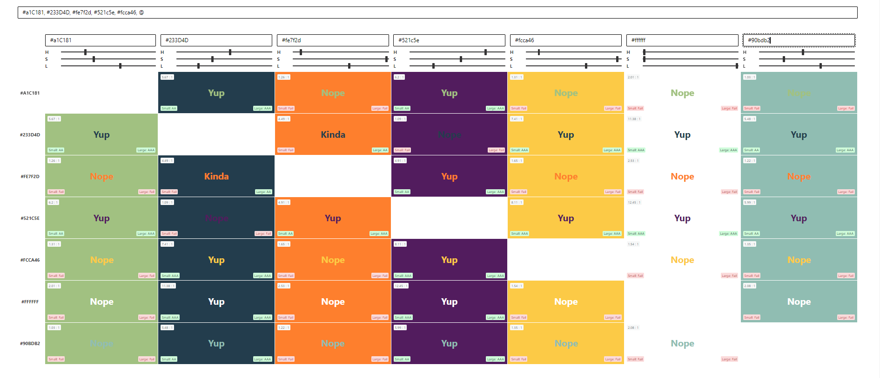
Today’s presentation checked using https://www.aremycolorsaccessible.com/

Author

Beth Adams - MA, LSSBB (she/her)
elizabeth.adams@dshs.wa.gov
ALTSA Lean Continuous Improvement Manager
ALTSA Organizational Development, Office of the Assistant Secretary

