Results Washington is updating its approach to public reviews - What’s next?

Results Washington is refocusing its efforts and will partner with state agencies to tackle complex, cross-enterprise topics. Agency Deputy Directors will be invited to meetings in June/July 2020 to identify areas for improvement within the Governor’s five Goal/Focus areas (see next page). The purpose of these upcoming Public Performance Review Agency Leader Meetings is to identify potential cross-enterprise projects to work on together in CY21.

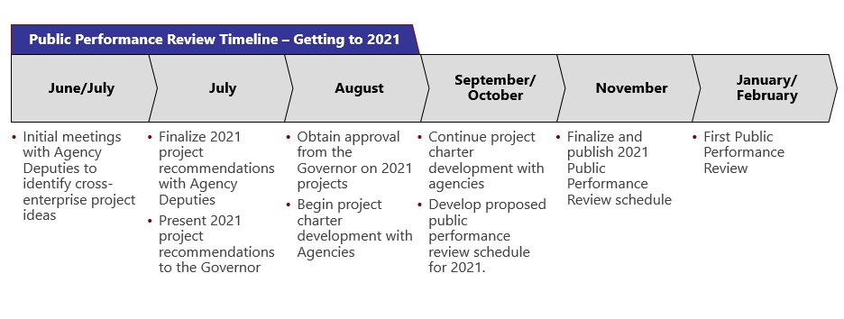
How is the new Public Performance Review process different than previous iterations?
- Cross-enterprise agency priorities within the Governor’s five Goal/focus areas will lead the way
- Focus is on outcomes with an improved level of up-front clarity, scoping, and commitment prior to pursuit of any projects
- Results will serve in a coordination and facilitation role before, during, and after the Public Performance Reviews

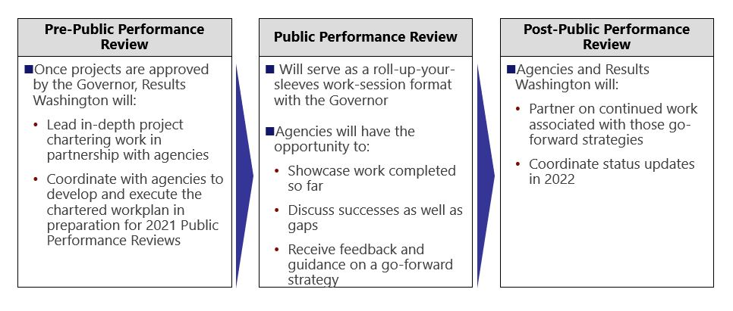
Christy Bezanson | Director | christine.bezanson@gov.wa.gov | 360.280.3662

What will we do in the upcoming Public Performance Review Agency Leader Meetings?
- The Governor’s Office and OFM staff have provided input on key focus areas within the Governor’s five Goal Areas for CY21
- Our work in the upcoming meetings will center on identifying potential cross-enterprise projects to work on together in CY21
- Results Washington staff will facilitate the meeting discussions and use your input to develop a list of potential projects

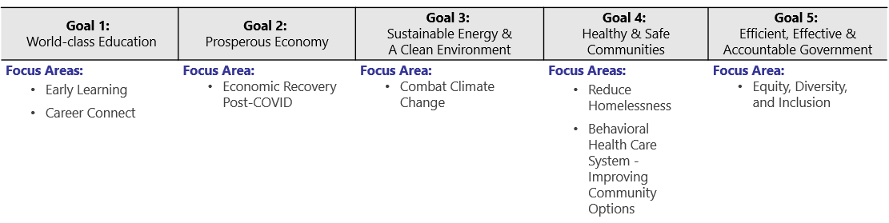

Preparing for the Public Performance Review Agency Leader Meetings
- For each Public Performance Review Agency Leader Meeting you will attend:
  - Think about your agency’s priorities within the Focus Areas. What opportunities do you see for cross-enterprise problem solving or improvement?
  - Consider impacts related to our current public health and/or social/societal situations
  - Consider alignment with the Governor’s priorities
  - Come prepared with ideas!

