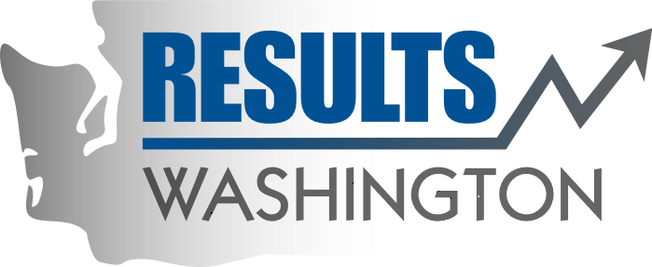

Governor’s Results Review Agenda

Improving the graduation rates for Students with Disabilities

Date: | September 26, 2019
Time: | 10:30-12:00
Location: | Helen Sommers Building, Room G015, 106 11th Ave SW, Olympia, WA 98504

Time | Topic | Participants
10:30 – 10:40 | Welcome | Mandeep Kaundal, Results Washington  Governor Jay Inslee
10:41 – 10:50 | Student Story: | - Aaron James, Student  - Sarah James, Parent and Educator
10:51 – 10:55 | Q&A | Governor Jay Inslee
10:56 – 11:20 | Governor’s Special Education Policy Initiatives/Focus  Graduation rates gaps and recommendations | - Maddy Thompson, Senior Policy Advisor, Gov’s Office  - Cynthia Hollimon, Budget Assistant, Special Education, Office of Financial Management (OFM)  - Glenna Gallo, Assistant Superintendent, Special Education Services, Office of Superintendent of Public Instruction (OSPI)  - Kris Hirschmann, Director of Transition Services, Seattle University
11:21 – 11:25 | Q & A | Governor Jay Inslee
11:26 – 11:48 | Creating inclusive and supporting cultures in schools and communities | - Carrie Basas, Education Ombuds Director, Gov’s Office  + Carrie Basas interviews:  - AJ, Student  - Michelle Siadal, Meridian Parent Partnership  Program (MP3) Principal,  Meridian School district  - Scott McCallum, Superintendent, Washington State School for the Blind (WSSB)  - Rick Hauan, Executive Director, Washington Center for Deaf and Hard of Hearing Youth (CDHL)
11:49 – 11:55 | Q & A | Governor Jay Inslee
11:56 – 12:00 | Closing Remarks | Governor Jay Inslee  Mandeep Kaundal, Results Washington

